# Career News Term 1, Week 4, 2023 from Mr David Russell, Curriculum Coordinator (7-12) / Student Advisor (7-12)

# University of Newcastle News

**NEW EARLY ENTRY PROGRAM**

This year we are excited to announce our NEW EARLY ENTRY PROGRAM. Our Early Entry Program provides students with the chance to receive an offer to the University of Newcastle before the HSC*.

Applications are FREE.

Early Entry Program benefits include:

* HSC study support to help students achieve the best results from Year 12
* Free preparation courses to make sure students get the most out of Uni
* Invitation to VIP events throughout the year
* Invitation to our student leadership program

We are currently working with UAC to finalise details of the program including confirming application and offer dates in the coming weeks.

For more information visit [//newcastle.edu.au/early](https://www.newcastle.edu.au/early)

*\*Offers contingent on completion of the HSC.*

**2023 KEY DATES**

Below a list of some of the University of Newcastle key dates for the year ahead. Further information on the activities below will be provided soon, including RSVP and registration information.

|  |  |  |
| --- | --- | --- |
| **DATE** | **UNIVERSITY EXPERIENCE** | **AUDIENCE** |
| 2 May | Parent Info Session  *Location TBC* | Parents/Carers of  Y12 Students |
| 10 May | Joint Medical Program Info Session Webinar  *Zoom Webinar* | Y12 Students |
| 31 May | Y10 Subject Selection Webinar – Parent Info Session  *Zoom Webinar* | Y10 Students and Parents/Carers |
| 29 July | Central Coast Open Day  *Ourimbah and CCCS Gosford Campuses* | Whole School Community |
| 26 August | Newcastle Open Day  *Callaghan and Newcastle City Campuses* | Whole School Community |
| TBC | Schools Visit Day  *Callaghan Campus* | Y11 and Y12 Students |
| TBC | Schools Visit Day  *Ourimbah Campus* | Y11 and Y12 Students |

# University of New England (UNE) News

If you are interested to study at UNE after leaving Year 12, you might like to consider applying for early entry to UNE. Early entry doesn’t mean you start University early, it just means you get an offer for a course at the University before the main offers are made.

Applications are open now, the process is free, easy to complete and completely online.

UNE's Early Entry has been running successfully for over 30 years. Early Entry is open to all Year 12 applicants and relies on their school assessment of student attributes, abilities and potential for academic success at university.

Students can apply to UNE receive an offer and secure a place at university, even before ATARs are released. This gives students certainty to begin making other arrangements such as where to live and finding part-time work.

For more information, visit [Early Entry - University of New England (UNE)](https://www.une.edu.au/study/study-on-campus/early-entry?utm_campaign=2024%20T1%20Applications%20open%20-%20registered%20schools&utm_medium=email&utm_source=Eloqua)

# UAC News – Talk for Year 12

A talk by UAC is scheduled for 7th March for Year 12 students to be held at school via Zoom.

A longer Year Meeting is planned for this day which is to start at 9:30.

The talk will cover the following topics during the session:

* what the ATAR is,
* how the ATAR is calculated,
* Scaling, why?
* the UAC application process,
* Educational Access Schemes,
* Schools Recommendation Schemes (early entry),
* Equity Scholarships,
* Adjustment Factors & selection ranks,
* Offers

# UNSW News

|  |  |  |  |  |  |  |  |  |  |
| --- | --- | --- | --- | --- | --- | --- | --- | --- | --- |
| |  |  |  | | --- | --- | --- | | |  |  | | --- | --- | | |  | | --- | |  | | | | |  |  |  |  |  | | --- | --- | --- | --- | --- | | |  | | --- | | **Register for our Year 12 Medicine Information Evening** | | **Tuesday, 14 March 6.30–7.30pm**  Year 12 students are invited to join us online to hear from our academic experts, current students and advisers as they explore our Bachelor of Medical Studies/Doctor of Medicine program’s dynamic blend of hands-on clinical experiences and research-focussed learning, as well as the admissions process for 2024 entry. | | |  | | --- | | [Register here Read more](https://www.eventbrite.com.au/e/unsw-year-12-medicine-information-evening-tickets-538385735227?aff=EducatorsNewsletter&_cldee=kdPHO9elG54Xx7At9zimCpfhdDZipQALXhX4SzOxsjOVyZMYaLh5nUFdZyTXbmev&recipientid=contact-411c6229e34fe71180f970106fa39b51-527718e0aa5c48b4861e672c819f8f88&utm_source=ClickDimensions&utm_medium=email&utm_campaign=nurture&esid=efc387d7-ebab-ed11-83fe-00224814340a) | | | |

# Central Coast Apprenticeships and Traineeships

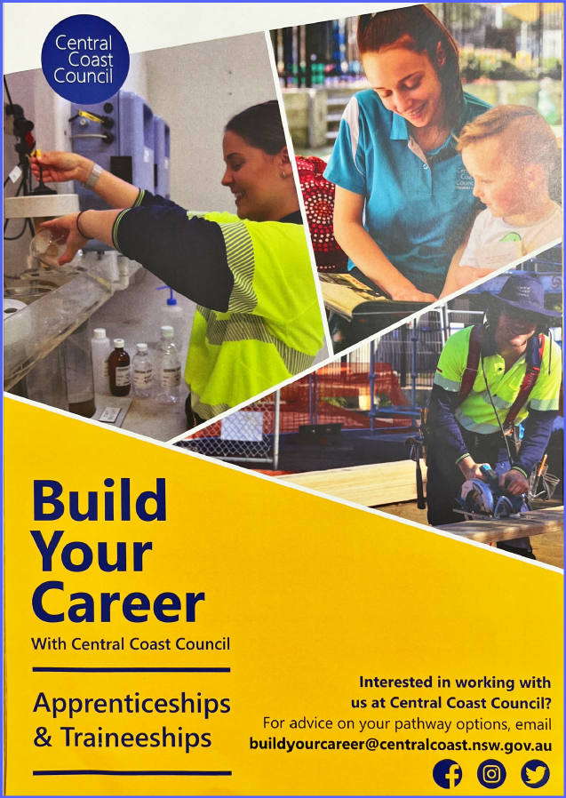

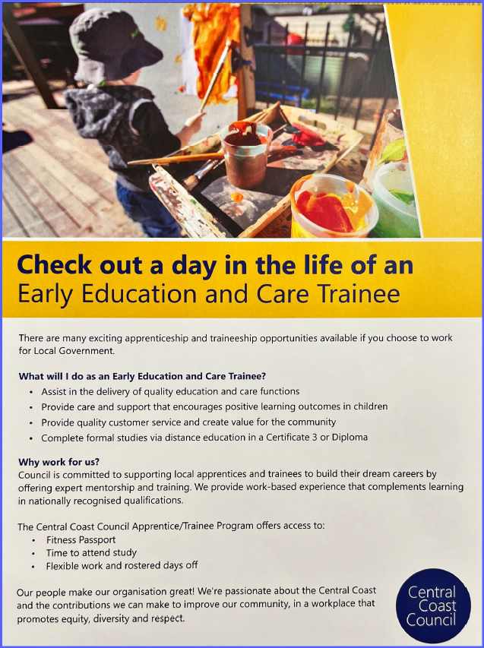 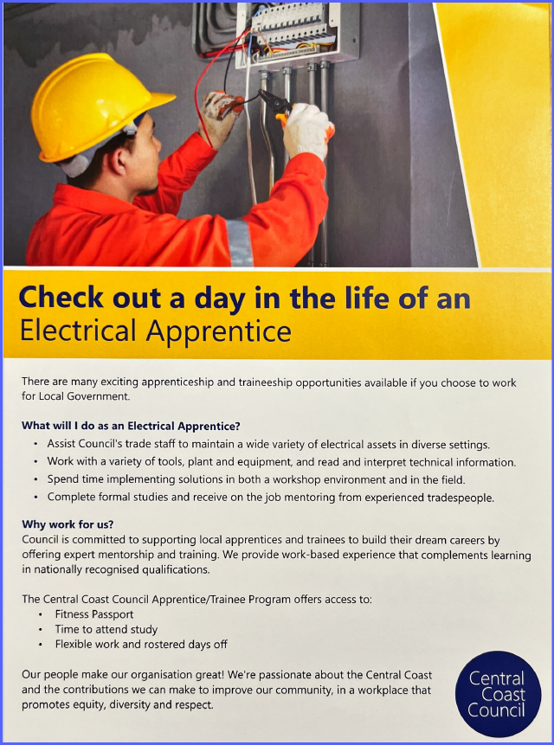

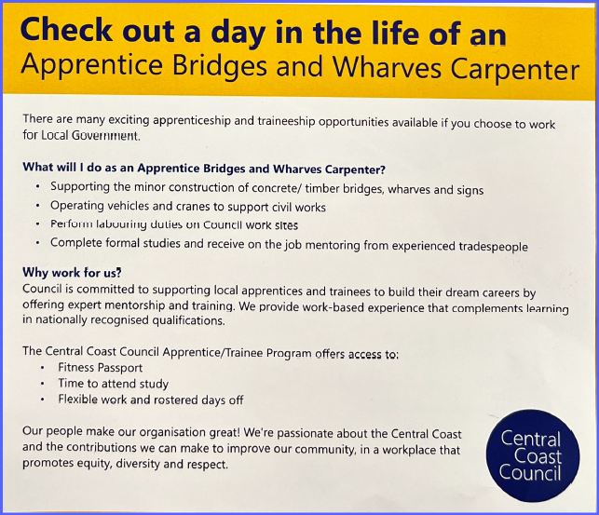

# Interested in a Career as a Dental Assistant…?

|  |
| --- |
| edm banner-Feb-15-2023-10-13-18-0240-PM |
| HCFExplore a rewarding career in Dentistry! At HCF - Australia’s largest not-for-profit health fund, we cover over 1.8 million members. Our vision is to make healthcare understandable, affordable, high quality and member centric.   We are looking to recruit Trainee Dental Assistants for our Sydney Dental centres which are located across the city. On joining you will be provided with a competitive salary and on-the job training as well as the opportunity to complete the Certificate III in Dental Assisting through Tafe, which will be funded by HCF.   By joining one of our Dental Centres, you will become part of a friendly, dynamic team that puts our members and their health first. |

|  |  |
| --- | --- |
| |  | | --- | | [**Click here to learn more and apply now!**](https://explorecareers.com.au/employers/hcf/?content=jobs) | |

# Job Opportunities

# Apprentice Plumber

* PAID to study a Certificate III in Plumbing
* Full-time position based out of Morisset
* White card essential

**Are you ready to design a future you'll love?**  
Kick-start your career with Central Coast Group Training - the Coast's leading employer of Apprentices and Trainees for over 40 years!  
  
**WHO YOU'LL BE WORKING WITH...**  
Our Host Employer is a family-owned plumbing company who has been in business for over 42 years. Providing gas-fitting and plumbing services from the Central Coast to Port Stephens, they specialise in working on new builds and estates only.  
  
**WHAT YOU'LL NEED...**

* White card
* Drivers license
* Strong work ethic
* Eagerness & commitment to continuing Apprenticeship

To be considered for this position, you will have strong communication skills, be hard-working, and be eager to complete your trade.  
  
**WHAT YOU'LL BE DOING...**  
Working Monday to Friday, 6:00am to 2:00 pm, with the potential for overtime and weekend work. Your duties will include, but are not limited to;

* General plumbing repairs including diagnosing
* Liaising with other staff & clients
* Assisting with job set up and pack down
* Planning and scheduling
* Hot and cold water and appliance installations
* Drainage installations
* Fitting off's

As part of this Apprenticeship, you will be PAID to continue studying a Certificate III in Plumbing through OFF Job Training at TAFE NSW Wyong Campus.

# General News

**University - Institutes**

**UOW Open Day - Save the Date**

5th August

The University of Wollongong (UOW) Open Day is the perfect opportunity to visit our amazing Wollongong campus, speak with our staff and students, and see why UOW is ranked as one of the best universities for student experience.

Sign up to our Newsletter for the latest updates.

<https://www.uow.edu.au/openday/>

**University of Sydney Seminar - Putin, History, and the Ukraine War**

1 March

Commentary on the Ukraine War is full of historical allusions and comparisons. In his own speeches on the war, Russian President Vladimir Putin often refers to earlier periods in Moscow’s relationship with neighboring regions such as Ukraine—from tsarist times, through the Russian Revolution, to WWII and its aftermath. What is Putin's view of Russian history, and what can this tell us about his view of Russia’s role in the world today?

<https://uni-sydney.zoom.us/webinar/register/WN_oFio0AklSXWJsHmMA4rQtw>

**University of Sydney Seminar - The Digital History of Human Rights: How a History degree prepares you to work with Big Data**

22 March

Find out how a team of historians, librarians, and data scientists worked together to reimagine the history of human rights. New digital tools are revolutionising the way in which historians interpret the past. A ‘Big Data’ approach has made it possible for historians to map how human rights movements have evolved over time on an unprecedented scale.

<https://uni-sydney.zoom.us/webinar/register/WN_wsqTEnWCQ5qb3iMeHWq2PA>

**University of Sydney Seminar - Interaction Design at Sydney**

29 March

Learn about how our new Bachelor of Design (Interaction Design) will provide you with the innovative technical and social design skills to become a leading-edge designer in today's fast-paced job market. Find out how your passion for creativity and problem solving can be harnessed for a career in digital and visual design.

<https://uni-sydney.zoom.us/webinar/register/WN_7pdl_cGnSW2iYCiYUMsGnA>

**University of Sydney Seminar - Life of a Health Scientist**

22 March

Have you wondered what a day in the life of a health scientist might be like? And what jobs might be available? Health is one of Australia's fastest growing employment sectors. Join Dr Leigh Wilson to find out what an average day of work might be like in the field of health science and about our specialist Health program. Learn about how health scientists address broad issues in healthcare and work to improve health and wellbeing for individuals, families and communities worldwide

<https://uni-sydney.zoom.us/webinar/register/WN_U31nGtIXThS-Vnw9ySRJZw>

**University of Sydney Seminar - Bachelor of Advanced Computing**

29 March

Want to work for a major tech company like Microsoft, Oracle and Google? Or launch your own start-up? Then the Bachelor of Advanced Computing could be for you. Specialise in Computer Science, Cybersecurity, Software Development or Computational Data Science, as well as a second major from our shared pool of 100+ majors from across the University. From intelligent drones to virtual reality apps, cybersecurity to the Internet of Things, you will learn the design principles and programming skills to build the systems behind emerging technologies. Carve your own unique path with our accredited and flexible advanced computing program.

<https://uni-sydney.zoom.us/webinar/register/WN_Ope-tBQTTuOhWJYE59wJpg>

**University of Sydney Seminar - Bachelor of Commerce: Internships, Study Tours and other Work-ready Learning Experiences**

15 March

Discover how our Bachelor of Commerce will prepare you for the future of work. Find out how you will gain an edge with guaranteed, work-ready learning experiences integrated throughout your degree from our award-winning teams. From internships and global mobility opportunities to consulting projects and cultural immersion programs, discover how you can choose your own unique path to achieve your personal career goals.

You will also learn about the many ways you can combine your interests with our range of dynamic business majors as well as over 100 study areas from our shared pool of majors/minors.

<https://uni-sydney.zoom.us/webinar/register/WN__bK7U7_sRVCkRxjqcrvo4g>

**University of Sydney Chemical Engineering Work Experience**

May 2023

Hosted at the School of Chemical and Biomolecular Engineering, we offer work experience placements for Year 10 students who want to learn more about chemical engineering.

By participating in our interactive activities, students will gain insight into various industries where chemical engineers work and career pathways for chemical engineers. You'll undertake activities in areas that concern our industry partners.

<https://www.sydney.edu.au/engineering/industry-and-community/high-school-outreach/high-school-activities.html>

**ANU Tuckwell Scholarship – Applications now Open**

Opens 1 March

One of the most prestigious scholarships in Australia. The program has a focus on giving back to Australia and is the only one of its kind that nurtures Scholars to fulfil their broader community ambitions over and above the pursuit of an undergraduate degree.

Each year we award 25 Scholarships and offer talented and motivated students the opportunity to realise their potential by providing financial support, personal enrichment and development opportunities.

<https://tuckwell.anu.edu.au/news/applications-2024-scholarships-will-open-1-march-2023>

**ANU Open Day 2023**

18 March

ANU Open Day is your chance to tour our beautiful campus and accommodation, learn about our academic colleges, degree programs and support services, and chat to current students about campus life and their ANU experiences.

ANU. This is your place – a talented and welcoming community in Acton, at the heart of scenic Canberra. We can’t wait to meet you.

<https://openday.anu.edu.au/>

**Charles Sturt University Courses Offered Online**

Looking for the best online courses? You’ve come to the right place.

As Australia’s most experienced online university, we know study isn't your only commitment. That's why we make our online courses – undergraduate and postgraduate – super flexible.  Studying an online degree allows you to work within your own time frame, wherever you may be. That is just one of the benefits of online education.

We offer everything from short courses to bachelor's and master's degrees online, so you can study the way that suits you. At Charles Sturt University you can choose from hundreds of online courses available across 21 different career areas – all fully supported. Study support. Wellbeing support. Tech support. Because when it comes to juggling work, family and life in general – we've got your back.

<https://futurestudents.csu.edu.au/csu-online>

**CSU Explore Day 2023**

Albury-Wodonga - 7 March

Bathurst - 14 March

Wagga Wagga - 21 March

Port Macquarie - 28 March

Are you in Year 10, 11 or 12? Explore Day is your chance to check out what life at Charles Sturt University is like – but with a twist!

Keen to check out where you’ll be staying? You’ll get to take a look at our accommodation and tour our campus, chat with students and get the lowdown from lecturers. There’s even a free lunch and a swag bag of goodies. But the best bit about Explore Day? You can get involved! Pick which interactive session/s interests you, book your spot and then get set for some hands-on learning that’s also a whole lot of fun.

Each of our Explore Day campuses will run different sessions on everything from arts to vet science. There’s lots for you to explore.

<https://study.csu.edu.au/life/events/explore-day>

**SCU - Early Offer**

Applications open April 2022

Take the stress out of Year 12 with an Early Offer

The Early Offer program allows you to secure your place in a Southern Cross University degree before your Year 12 results are even released. It’s designed to remove some of the pressure from Year 12 and give you a pathway directly into university study that is not based solely on your Year 12 results. This program allows you to gain an offer into a Southern Cross University course *, based on your grades and your school principal’s recommendation.

<https://www.scu.edu.au/early-offer/>

**UNSW Year 12 Medicine Information Evening**

14 March

Are you interested in a career in medicine?

Start your medical career at one of the top 50 medical schools in the world.* Studying the Bachelor of Medical Studies/Doctor of Medicine at UNSW will provide you with the theoretical understanding and practical experiences you need to launch your career as a medical professional.

UNSW’s Medicine Information Evening, for current year 12 students, will provide insight into the dynamic blend of hands-on clinical experiences and research-focused learning that you will be immersed in as a UNSW Medicine student. You’ll also find out detailed information on the application and admissions process for 2024 entry, including special entry schemes such as Rural, Gateway and Indigenous Entry Schemes.

<https://www.events.unsw.edu.au/event/year-12-medicine-information-evening-1>

**UNSW Seminar - How Will Climate Migration Reshape Our World?**

9 March

Floods, fires, drought and disasters are already displacing more people globally than conflict.

The climate emergency is destroying crops, homes and infrastructure and as the world heats over the coming decades whole cities may become unliveable, forcing populations to move in their tens of millions. How can we manage this unprecedented human movement to achieve productive, sustainable societies this century?

Join award-winning science writer and the author of *Nomad Century: How Climate Migration Will Reshape Our World* Gaia Vince, for a keynote talk, followed by a conversation with *Guardian Australia’s* immigration reporter Ben Doherty and Director of the Kaldor Centre for International Refugee Law Jane McAdam about how climate migration will reshape our world.

<https://www.events.unsw.edu.au/event/how-will-climate-migration-reshape-our-world>

**Lab tour opportunity for maths & physics students at UNSW, Sydney**

SPREE invites all maths and physics students to visit us at UNSW, Sydney. Here you can take a guided tour of all of our labs, including the Solar Industrial Research Facility—where many of the world’s solar cells and panels are tested and produced for major solar companies.

Email e.keep@unsw.edu.au ('lab tour request' as subject)

to express your interest

**UNSW Key Dates 2023**

March 14 - Medicine Information Evening

April 18-20 - Year 10&11 On Campus Experience Days

May 1 - Co-op applications open

May 3 - Law Admissions Test Information Evening

May 11 & 23 - Year 10 Info Evening: Subject Selection

May 17 - UCAT Applications Close

June 13 & 15 - Year 12 Information Evenings

July - Most UNSW Scholarships Open

August - EAPL Adjustment Factor Scheme Applications Open

September 2 - UNSW Open Day

September 30 - UAC Early Bird Preferences Close

September 30 - UNSW Medicine Application Portal Closes

September 30 - UNSW Scholarship & Co-op Applications Close

November 30 - EAPL Applications Close

**University - General**

**ComparEd Empowering decisions, inspiring opportunities.**

Thinking about higher education study? Wish you could ask someone about their experience?

Explore and compare institutions and study areas based on real life student experiences.

With ComparED, you can explore and compare the quality of higher education institutions and study areas you are interested in, based on the experiences of others.

Be empowered to choose what’s right for you!

Search institutions or study area.

Empowering decisions, inspiring opportunities

<https://www.compared.edu.au>

**Bond University Pathways to Psychology Webinar**

22 March

Becoming a registered psychologist is a long journey - but it's an extremely rewarding one. At Bond, our accelerated psychology programs mean you can get a headstart on your path to becoming a registered psychologist and making a difference in the lives of others. Let us take you through the steps.

<https://bond.edu.au/event/5748/pathways-to-psychology-webinar>

**Bond Business School Year 12 Extension Program**

Get a head start on your studies with the Bond Business School Year 12 Extension Program, which comprises fast-paced and fun two-day workshops designed to prepare you for university life. Facilitated by our world-class academics, the Extension Program offers an enriching opportunity that supports the existing Year 12 curriculum across areas such as business and maths. Faced with real-world situations, participants will hone their skills, problem solve, and work collaboratively with their peers. The Extension Program is free of charge to students.

Upon the successful completion of a two-day Extension Program workshop, eligible students will receive early entry into their program of choice, and top performers may be offered one of six part-fee (25% and 50%) scholarships or a $5,000 bursary.

<https://bond.edu.au/event/6206/year-12-math-extension-program>

**Bond Psychology Experience Day**

27 April

This event is complimentary for Year 10, 11 and 12 students and one parent.

Have you ever wondered what it is that makes you, you? Find out more about the fascinating study of the human mind at our Psychology Experience Day! Love, Sex & Relationships, Drugs & behaviour, Motivation & Emotion, Learning & Behaviour… these are just a few of the subjects you will take that will allow you to explore human society, social relationships and human interaction with technology, at Bond. Study a program fully accredited by APAC and with a guaranteed offer for 4th Year studies* at the Bond University School of Psychology!

<https://bond.edu.au/event/6199/psychology-experience-day>

**University of Melbourne Hansen Scholarship Information Evening**

21 Feb

Are you a young leader in the making? Do you want to broaden your academic horizons while exploring your unique passions?

Applications for the Hansen Scholarship Program, the University's most generous undergraduate scholarship, are open between February and March 2023. Valued at up to $108,000, the scholarship recognises Year 12 students from across Australia who have demonstrated outstanding academic success, a resilience to adversity and a commitment to helping others within their community.

To help you learn more about the program, we're inviting you to our upcoming online information session, in which we'll cover:

* The program's eligibility and selection criteria
* Timelines and the application process
* Tips and advice on submitting a competitive application

Benefits of the program, including financial support, tailored personal development, industry connections and free accommodation at Little Hall residence.

You’ll also hear from a current Hansen Scholar who will share their experiences about the program and be available to answer your questions. Parents and careers practitioners are also welcome to attend.

<https://study.unimelb.edu.au/student-life/events/hansen-scholarship-program-information-evening>

**From ANZ To The Most Competitive University In The World: HARVARD!**

22 Feburary

Meet NZ student Koan Hemana, hear his story and ask him questions about how he got accepted to Harvard at our FREE live webinar on Wednesday 22nd February at 5:30pm AEDT. Take the first step towards studying at your dream university by registering now!

<https://www.crimsoneducation.org/au/campaign/from-anz-to-harvard-koan-hemana/>

**Simulated UCAT Day Workshop: 2-part program**

If you are in Yrs. 10, 11, 12, or you may be older and considering sitting the UCAT in the future, then this program is for you. The Simulated UCAT Workshop program is ideal and often a necessary step towards effective and efficient preparation for the UCAT.

This event will be conducted by the National Institute of Education in partnership in partnership with UCAT Preparation Australia, and MICAS (Medical Interviews and Career Advice Services).

The workshop is primarily designed to cover fundamental techniques in navigating all five sections of the UCAT test and also for participants to gain a better understanding of their own level of preparedness for the test.

<https://www.nie.edu.au/ucat-courses/simulated-ucat-day-workshop>

**TAFE**

**The Best Jobs for School Leavers and TAFE NSW Can Help**

TAFE NSW has a list of awesome jobs for school leavers to get their hands dirty and earn good coin. From Barista skills making that perfect cup of coffee to serving the country in the Defence Force, we’ve got courses for your students ready to leave school:

<https://www.tafensw.edu.au/career-advice/start-my-career/blog/-/blogs/top-6-jobs-for-school-leavers>

**Maxima Indigenous Traineeships and Apprenticeships**

Maxima is a leading Group Training Organisation – we manage the recruitment, placement and ongoing support of apprentices and trainees on behalf of host employers.

We aim to help you kick-start your career into the job or industry of your choice, boost your employment credentials and equip you with the skills and knowledge to be able to succeed in the future.

Maxima also offers school-based apprenticeships and traineeships to senior students, allowing you to combine your secondary school studies with paid employment as an apprentice or trainee (on-the-job training) and off-the-job training.

<https://maxima.com.au/apprentices-trainees/apprenticeships-traineeships/>

**What are the Steps to an Australian Apprenticeship?**

Searching and applying for an Australian Apprenticeship is very much like hunting for any job. An employer has to create a vacancy and decide to use Australian Apprenticeships as a way to employ and train their staff.

The following steps will explain the process of getting an apprenticeship or traineeship, from the research stage to when the training begins. Click on each of the steps to find out more about what is involved in each stage.

<https://www.aapathways.com.au/job-hunting/steps>

**Sarina Russo Apprenticeships - Become an Apprentice**

We connect employers, apprentices and trainees to the right tools, resources and support to build the skilled workforce of tomorrow. Our team provides access to:

* wage subsidies and other financial incentives
* administration, registration and compliance support
* retention through ongoing mentoring, guidance and workplace support
* recruitment, online job boards and digital apprenticeship management tools

<https://www.sarinarusso.com/apprenticeship/>

**WPC Group - Apprenticeships & Traineeships**

Automotive, Hospitality, Business, Carpentry Electrical, Fitter Welder, Horticulture

WPC Group not for profit specialises in Apprenticeships & Traineeships. We discuss apprenticeships and traineeships with students, and can assist with mock interviews, resume writing and preparing students for the workforce. Today, we employ and train more than 650 apprentices and trainees through national programs.

<https://www.wpcgroup.org.au>

**Private Colleges**

**The Australian College of Physical Education Campus Tours - Health, Sport, Dance**

Mondays and Thursdays every week.

10 Parkview Drive, Sydney Olympic Park

We’d love to show you around our purpose-built campus in the heart of the Sydney Olympic Park. Tours run regularly on Thursdays each week. Lock in your spot and select an upcoming tour date and time now. We look forward to meeting with you and showing you around ACPE.

To lock in a day and time simply follow the link below and fill out the form.

<https://acpe.edu.au/about-us/events/>

**Commercial Pilot - BASAIR Career Free Info Seminar**

Next Seminar - 13 March

628/23-25 Airport Avenue, Bankstown Airport

Learn about a career as a Commercial Pilot at one of our free information seminars. Basair Aviation College runs monthly seminars in Sydney, Brisbane and Newcastle. Learn more about a career in aviation and the benefits Basair can provide for your training as a commercial pilot.

<https://basair.com.au/seminar-events/sydney-pilot-career-seminar-mar-14-2022/>

**Interior Designers! Sydney Design School Open Day**

On Campus Saturday 20 May 2023. 10am – 12pm

Join us for our biggest day of the year! Our Director Amanda Grace will take you through our flexible course options. Meet our passionate Educators and Careers Coach while exploring our inspiring student work.

If this event is moved online we will update you with a link to join us via Zoom. You can expect to receive this closer to the event date. Make sure you register below.

<https://sydneydesignschool.com.au/information-sessions/>

**Brent Street Autumn Camp**

17th – 19th April

Don’t let your dancing fall behind in the school holidays – join us for 3 epic days of dancing, singing and acting at our world-famous studios. You’ll leave the workshop feeling inspired and pumped, exposed to a whole new range of styles and teachers, ready to smash your dance goals for Term 2 and beyond!

We welcome students from all studios across Sydney and Australia to enjoy our Autumn Camp. It’s so much more than just dance classes; it’s an experience of making friends, a physical challenge and inspiring teachers!

<https://brentstreet.com.au/workshops/autumn-camp-2023/>

**JMC Games Design Work Experience 2023**

Applications Close 31 March

Runs 29 May - 1 June

WANT TO KNOW WHAT GAME DESIGN MEANS?

This is a 4-day program where you’ll be introduced to the workflow of game design!

(And no, just because you love to play games, does not mean you will enjoy working in games)

The JMC Game Design work experience program is for Year 10 – 11 students and will be conducted on our Sydney campus.

There are limited number of space available and currently this is the only time the program will run.

<https://www.jmcacademy.edu.au/news-and-events/events/game-design-work-experience-2023/>

**General**

**So you don’t have work experience? How to stand out**

Tips on how to get experience to impress an employer. It can be hard to get a job if you have no work experience. There are some things you can do to get work experience, even if you haven’t worked in a paying job yet. These things will help you stand out without work experience.

<http://www.youthcentral.vic.gov.au/jobs-and-careers/applying-for-a-job/how-to-stand-out-without-work-experience>

**Discover Your Interest in a Gap Year with the Air Force**

Spend an exciting 12-months in the Air Force, where you'll get paid for meaningful work while travelling around Discover a Gap Year with the Air Force

Australia, gaining skills for life, and making lifelong friends. Don’t miss out on this unique experience, submit your expression of interest below to receive updates when Gap Year opens.

Spend an exciting 12-months in the Air Force, where you'll get paid for meaningful work while travelling around Australia, gaining skills for life, and making lifelong friends

<https://airforce.defencejobs.gov.au/students-and-education/gap-year?page=1&perPage=21&query=>

**Past HSC Exams Papers**

Higher School Certificate exam papers, with marking guidelines and HSC marking feedback , are available for each course. Select a learning area from clicking the link below to see exam paper packs by course for each HSC year.

<http://educationstandards.nsw.edu.au/wps/portal/nesa/11-12/Understanding-the-curriculum/resources/hsc-exam-papers>

**Tech Careers Booming in Finance**

Sending cash fast, fighting off crims and protecting our economy: all in a day’s work at Australia’s Central Bank

Banking has come a long way from coins weighed on old-school scales and hand-written cheques and contracts. Behind the scenes in banking, a technology and innovation boom is underway. And if you want a high-tech career in the world of banking, Australia’s Central Bank, the Reserve Bank of Australia (RBA) is where it’s at.

<https://careerswithstem.com.au/tech-careers-in-banking-rba/#gsc.tab=0>

**Careers at Council**

This is the industry's go-to source of information about work in local government. Explore the many and varied roles in the Career Areas section.

<https://www.careersatcouncil.com.au/career-areas/>

**NSW Police Recruitment Information Session**

18th Feb

Come and join us for an information session about the NSW Police Force recruitment process. The session will provide an overview of the academic and professional suitability requirements for entry into the NSW Police Force including information on the University Certificate in Workforce Essentials (UCWE) and the Police Academy. Recruitment Officers will be on hand to discuss your current or future application and to answer specific questions relating to the process.

<https://www.facebook.com/events/557796089364377>

**5 reasons to launch your STEM career into space**

Australia’s space sector is taking off – here’s why you should be a part of it.

<https://careerswithstem.com.au/space-career/>

**The A-Z of space careers**

Australia’s space sector is taking off, and there are loads of ways you could be a part of it

With the space industry predicted to triple in size over the coming decade here in Australia, space-related careers are on the up! Lookout for these out-of-the-box next-gen roles. Astronaut not included…

<https://careerswithstem.com.au/a-to-z-of-space-jobs>

**2023 Newcastle Career Expo & Lake Macquarie**

18th May

Advice from Uni, TAFE and other tertiary education, trades, businesses and career support agencies.

<https://www.newcastlecareerexpo.com.au>

**Love Animals? Taronga Talks - The podcast from Taronga**

Working at Taronga Zoo is more than just a job – for us Taronga means family.

The deep connections our staff develop with wildlife and the natural world affects the lives of others, near and far. From Sydney to Dubbo, Taronga’s people all have amazing untold Zoo stories that will touch your heart and open your eyes.

<https://taronga.org.au/get-involved/taronga-talks#latestepisode>

**The Hour of Code**

The Hour of Code started as a one-hour introduction to computer science, designed to demystify "code", to show that anybody can learn the basics, and to broaden participation in the field of computer science. It has since become a worldwide effort to celebrate computer science, starting with 1-hour coding activities but expanding to all sorts of community efforts.

<https://hourofcode.com/au>

**Careers in Maths**

See how different people in a wide range of careers use maths as part of their daily routine at work. The site increases Australia’s mathematically capable workforce through hundreds profiles, videos, jobs. Delivering maths careers materials to students and is committed to working towards increasing Australia’s mathematically capable workforce through hundreds of profiles, videos and jobs.

<https://careers.amsi.org.au>

**Country Education Foundation Uni Survival Guide**

Accommodation, part time work, health services and support advice for country students

<https://cef.org.au/university-survival-guide/>

**Country Education Foundation Grants**

Your local Country Education Foundation (CEF) supports youth in your area through financial grants for education and employment expenses. Our grants contribute towards apprenticeships, traineeships, cadetships, diplomas, certificate level studies, university qualifications or employment.

<https://cef.org.au/our-grants/>

**Careers Harvest**

Great website on all career fields and pathways on the land, environment and agriculture. Explore career options, scholarships and internships on offer.

<https://www.careerharvest.com.au>

**Land, Environment and Agriculture Scholarships**

Careers Harvest provides a directory for scholarships in the field of agriculture, land and environment.

<https://www.careerharvest.com.au/scholarships>

**How to Survive Year 12**

The thought of embarking on your final year of school can trigger a range of emotions — excitement, nervousness, stress, nostalgia, anxiety, sadness or just impatience to get out into the world. Whether you’re excited to have taken the next step or are just hanging out for the end, we provide some tips to help you get through Year 12.

<https://www.gooduniversitiesguide.com.au/education-blogs/tertiary-study/year-12-survival-tips>

**Virtual Internships - Challenges Abroad Australia International Volunteering**

Want to get a real taste for overseas community development? Our virtual internships give you the opportunity to spend 3-5 weeks working with our overseas teams to solve complex issues. This program will allow you to develop your skillset and contribute to international social impact, all from the comfort of your home. You'll gain international exposure while enhancing your employability and engaging directly with our in-country teams and community members. Virtual internships are available and on offer for both university and high school students looking to develop their skills and make an impact.

<https://www.challengesabroad.com.au/our-challenges/>

**Medical Work Experience for Year 10 and 11 Students**

We understand that getting medical work experience as a student can be extremely difficult. We offer young people from secondary and senior secondary school a safe, guided experience into the world of medicine through our High School Special Projects.

Our medical internships abroad for high school students focus on experiential education, so you learn by doing. You can expect to:

Shadow doctors and other medical professionals in busy hospitals and clinics

Attend medical workshops and seminars

Get first-hand insight into the healthcare challenges people face everyday

Participate in community healthcare outreaches that serve people in need

Learn essential medical skills like measuring blood pressure and blood sugar levels

<https://www.projects-abroad.com.au/medical-work-experience-teenagers/>

**UN Youth NSW State Conference 2023**

Friday 10 March 2023 (late afternoon) to Sunday 12 March 2022 at 5:00pm (overnight event)

﻿UN Youth New South Wales’ State Conference 2023 will see up to **two hundred high school students** from across the state meet at Collaroy Centre (Collaroy, New South Wales) to learn about **leadership, diplomacy and advocacy** and to take part in the **global conversation about international law**. At State Conference, you **will form friendships with a diverse array of students** from all around New South Wales and **become inspired to deliver change** in your community and globally.

The 2023 State Conference focuses on the theme of ‘Conflict in the Modern Age’ and spans two and a half days, giving students a whole weekend to make new friends from across the state! Delegates (students) will spend the first day of the State Conference meeting each other, getting involved with our interactive modern conflict workshops and tackling a simulated Interactive Problem Solving activity. The final day of State Conference is the Delegate’s chance to emulate a member state of the United Nations in Model UN committee debates. Get into a diplomat’s shoes for a day and do your best to pass resolutions that will benefit the global community and align with your national interests – not always an easy task.

<https://unyouth.org.au/event/nswconference/>

**Australian History Competition**

Registration Closes 31st March

Runs 29 May - 2 June

Not only is the Australian History Competition an opportunity to showcase that history is as important as maths, english and science, our delivery in hardcopy gets students away from screens in a fun and engaging way and helps them develop crucial skills in seeing different points of view. With a focus on testing interpretation and analysis rather than prior knowledge, the competition is accessible to year 7-10 students of all levels, giving every student the chance to excel!

<https://australianhistorycompetition.org.au>

**HOLD THE DATE! BiG Day In Parramatta**

18 May 2023

2023 BiG Day In Parramatta

IT Careers Conference

Peter Sheargold Building,

Level 9, Western Sydney University

Parramatta City Campus

Book your tickets early so your students don't miss out on awesome presentations from organisations such as Australian Signals Directorate, Wisetech Global, Australian Space Agency, Avanade Australia, TCS, Woolworths, Westpac & more to come.

<https://acsfoundation.eventsmart.com/events/big-day-in-parramatta-18-may-at-wsu-parramatta-cbd-campus/>

**Career win! Jobs in sportstech**

Hop, skip or jump your way into an exciting career using technology to make sports safer, more competitive and more fun

<https://careerswithstem.com.au/sportstech/>

**STEM + X Webinar Series: Science**

22 Feb

Science careers are more than just lab coats and experiments. The truth is, science is a really broad area to work in. People who have a science degree can work in government, in business, with the environment, or anywhere. Often without a lab in sight.

Join this free webinar to explore how you can combine a science degree with your ‘X’, which is your passion, another area or a big goal.

It’s Careers with STEM’s winning formula: STEM + X, where STEM is science, technology, engineering or maths, and X is up to you!.

Brought to you with the support of QUT, this webinar unlocks the next-level potential of a science degree.

Discover the careers of tomorrow and create change in our world today.

<https://us02web.zoom.us/webinar/register/WN_G3vHJFjkRg67_u9cLNuTJw>

**Save The Date - Frontiers of Science Forum**

24th March

Concord Golf Club, 190 Majors Bay Road, Concord

Registrations will open soon for our joint The Australian Institute of Physics / Teachers’ Guild of NSW / The Royal Society of NSW / Royal Australian Chemical Institute 4rd Frontiers of Science forum event in 2023.

**Quiz: What’s your STEM + sports career?**

Live and breathe sports and want to make it your career? STEM is still for you!

Athletes and sporting teams rely on science, tech, engineering and maths to keep them in peak physical and mental shape, and to improve performance, create gameplay strategies and develop efficient sporting equipment. There are so many exciting ways to mix STEM + Sports, and this quiz will help you narrow down where best to focus your talents!

<https://careerswithstem.com.au/stem-sports-quiz/>

**University of Sydney - Languages at Sydney campus day**

27 July

Language students, teachers and careers advisers are invited to join us for Languages at Sydney (LAS), our flagship campus experience program for languages.

LAS is a day event designed to give Stage 6 (Yr 11) students a taste of language-learning at the University of Sydney and a chance to hear about the benefits of language study beyond high school. The event will coincide with a lively time on campus as we welcome our students back for Semester 2!

Languages offered at Sydney are: Arabic, Chinese, Classical Hebrew, French, German, Indonesian, Italian, Japanese, Korean, Modern Greek, Modern Hebrew, Sanskrit, Spanish, Ancient Greek and Latin.

<https://www.sydney.edu.au/arts/study/events-resources-prospective-students/languages-at-sydney.html>